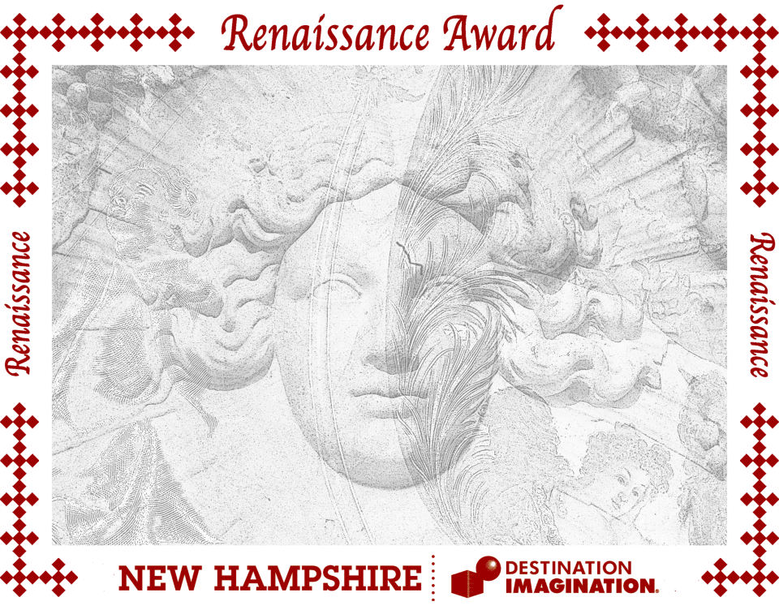

***Anna Maenhout***

New Hampshire Affiliate Director

New Hampshire Destination Imagination is proud to recognize

(Name of individual or team)

representing

(Name of school or organization)

at the tournament held

(Tournament date) at (Tournament location)

for extraordinary effort and preparation that demonstrated outstanding skill in engineering, design, or performance.